Command line Basic commands
This document provides a basic guide to using the command line, covering essential commands and shortcuts for navigating directories, managing files, and editing text. It aims to empower users with fundamental knowledge to interact with the command line efficiently.
- To open cmd in any folder:
From the folder you want to open in Command Prompt, hold the Shift key, then right-click an empty area. From there, select Open in Terminal or Open PowerShell window here.
Alternatively, change the folder path (at the top of File Explorer) to cmd. Press Enter to open CMD in that folder

- These are shortcuts for opening the Command Prompt on a Windows computer:
1. Press the Windows Key + R to open the Run menu, then type "cmd" and press Enter to open the regular Command Prompt.
2. To open Command Prompt as an Administrator, press Windows Key + R to open the Run menu, type "cmd," then press Ctrl + Shift + Enter.
3. Another way to open Command Prompt is by pressing Windows Key + X, using the arrow keys to select "Command Prompt," and then pressing Enter.
- To move to a directory:

>>> cd <folder name>,

where <folder name> is the position or directory where you want to move from current directory and make this directory as current directory (cd)

Examples:

>>>cd javaprograms (Folder name is javaprograms)

>>>cd .. (for one step back from current directory)

>>>cd ../../.. (for three step back from current directory)

Note: you can move only one directory forward in one step by assigning folder name but there is no limit for backward directory unless you come out of last directory.
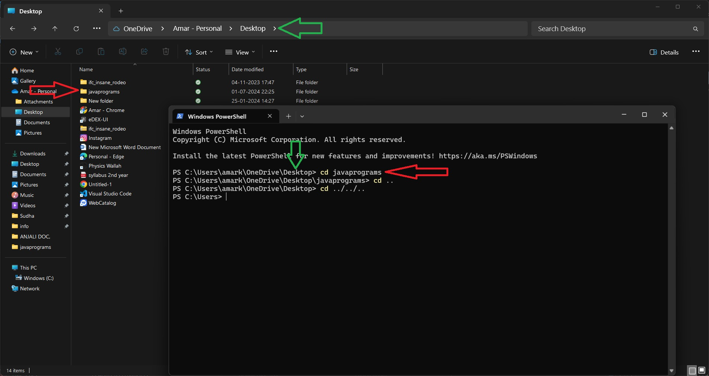

All commands there after is written in same way

Command Line Basic Commands and Shortcuts

To move to a directory:
Use the cd command followed by the folder name.

>>> cd <folder name>
Where <folder name> is the directory you want to move to from the current directory. This will make the specified directory the current directory.

Examples:
- Move to a directory named javaprograms:

>>> cd javaprograms
- Move one step back from the current directory:
bash
Copy code
>>> cd ..
- Move three steps back from the current directory:
bash
Copy code
>>> cd ../../..
Note: You can move only one directory forward in one step by specifying the folder name, but there is no limit for moving backward unless you come out of the last directory.

Basic File Operations:
- List files in the current directory:

>>> ls
- Copy a file:

>>> cp <source> <destination>
Example:

>>> cp file1.txt /home/user/documents/
- Move a file:
>>> mv <source> <destination>
- Example:
>>> mv file1.txt /home/user/documents/
- Delete a file:
>>> rm <file>
- Example:
>>> rm file1.txt
- Create a file:
>>> echo [Entire text] > <file>
- Example:
>>> echo Welcome viewers > Sudha.txt (here “Welcome viewer” is the text or content that would be written in file when you will open it )
- Create an empty file:
>>> echo “” > <file>
- Example:
>>> echo “" > Sudha.txt (here “” represent an empty file )
- Create a new directory:
>>> mkdir <directory name>
Example:
>>> mkdir new_folder
- Remove a directory:
>>> rmdir <directory name>
Example:
>>> rmdir old_folder

Viewing and Editing Files:
- View the contents of a file:
>>> cat <file> or >>> type <file name> | more
Example:
>>> cat file1.txt or >>> type mata.txt | more
- Edit a file by opening it in suitable app:
>>> <App name> <file name>
Example:
>>> notepad mata.txt
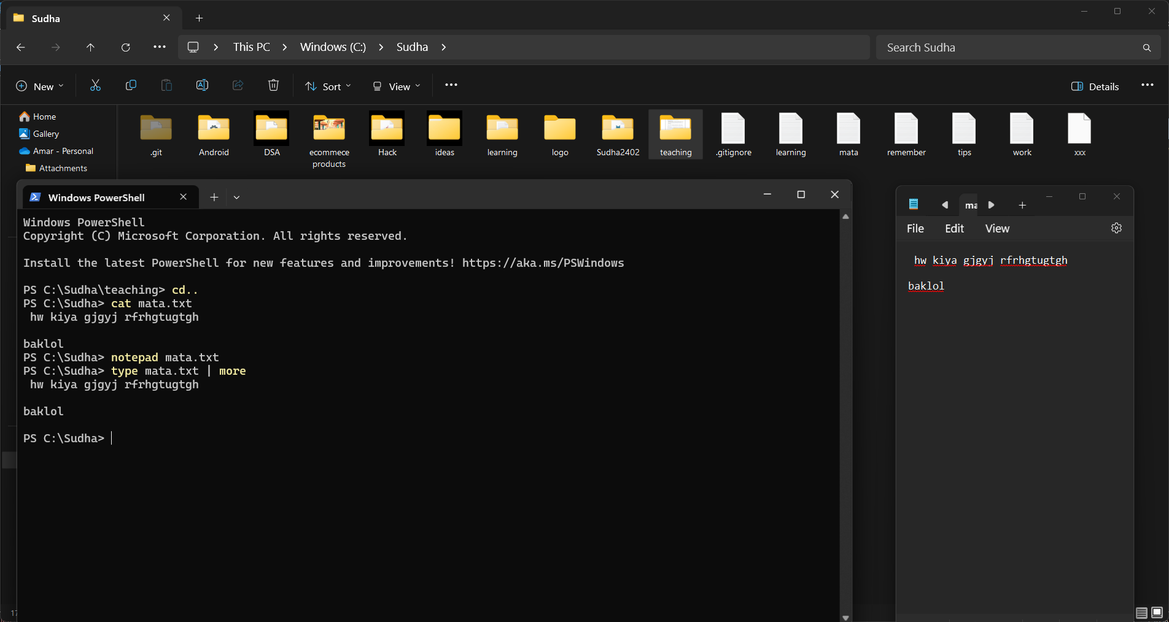
notepad

Shortcuts:
- Cancel a running command:
Ctrl + C
- Clear the terminal screen:
>>> clear or >>> cls
- Auto-complete file or directory names:
Tab
- Scroll through command history:
Up Arrow / Down Arrow
- Exit the terminal:
>>> exit

This should cover the basic command line operations and shortcuts.

